CEBU INSTITUTE OF TECHNOLOGY
UNIVERSITY

COLLEGE OF COMPUTER STUDIES

Software Requirements Specifications
for
CleverBee

Developers:

- Backend – Abarquez, Mykha
- Android – Giducos, Janine
- ReactJS – Garcia, Gianne

Project Description:

The Smart Study Planner is designed to assist students in managing their academic responsibilities more effectively. Many students find it challenging to prioritize their tasks, utilize effective study techniques, track their progress, and organize their study materials. This software solution aims to address these challenges by integrating task management, study techniques, progress tracking, and file management into one user-friendly application.

Functions:

- Task Management: Add, edit, delete, and schedule tasks; prioritize based on deadlines.
- Class Schedule Integration: Input and manage class schedules; auto-prioritize tasks based on class timings.
- Study Techniques: Implement Pomodoro Timer, Flashcards, Quizzes, and Study Tracker.
- Progress Tracking: Monitor task completion rates and study goals.
- File Management: Upload and organize study materials and notes.
- Personalized Study Recommendations: Suggest study techniques based on user preferences and activity levels.
- Map Integration: Show nearest libraries and study areas.

Overall Description

Product perspective

Context and Perspective
- Product Comparison: CLEVERBEE offers a comprehensive solution for task management, study techniques, progress tracking, and file management. Compared to other products, CLEVERBEE stands out by integrating all essential features into one platform, ensuring a seamless and user-friendly experience.

Product | Similar Functions
Todoist | - Task management (Add, Edit, Delete, Schedule tasks)  - Prioritize tasks based on deadlines  - Progress tracking (task completion rates)  - User registration & login
Google Calendar | - Class schedule management  - Auto-prioritize tasks based on class timings  - User authentication (Google account)  - Task scheduling with reminders
Trello | - Task management and prioritization (Boards, Lists, Cards)  - Progress tracking (task completion)  - User registration & login  - Collaborative features
Notion | - Task management (Add, Edit, Delete, Schedule tasks)  - File management (Upload, organize study materials)  - Annotate and categorize notes  - User authentication (Registration & login)  - Customizable study templates
Forest | - Pomodoro timer (Focus sessions)  - Track study sessions and effectiveness (Trees planted based on session completion)  - User registration & login
Quizlet | - Flashcards and quizzes  - Study session tracking (Number of sessions, effectiveness)  - User registration & login
Evernote | - File management (Upload and organize study materials)  - Annotate notes (highlight, comment)  - Progress tracking (Checklists, task completion)  - User authentication (Sync across devices)
My Study Life | - Class schedule management  - Task management (Assignments, exams, due dates)  - Progress tracking (Completion rates)  - User registration & login
Microsoft OneNote | - File management (Organize study materials, notes)  - Task management (Checklists, to-dos)  - Progress tracking (Tags, task completion)  - User authentication (Sync across devices)
Microsoft To Do | - Task management (Add, Edit, Delete, Schedule tasks)  - Progress tracking (Completion rates)  - User registration & login

- Independence: CLEVERBEE is an independent and fully self-contained product. While it integrates with external applications such as Google Drive and other Google Suite apps to enhance functionality, these integrations are supplementary and do not affect its core functionality..

User characteristics
- Student Users (Primary Users):
  - Role:
    - Access and utilize all core features of the application.
  - Privileges:
    - Task Management: Add, edit, delete, and schedule tasks. Prioritize tasks based on deadlines.
    - Class Schedule Integration: Input and manage class schedules. Auto-prioritize tasks based on class timings.
    - Study Techniques: Use the Pomodoro Timer, Flashcards, Quizzes, and Study Tracker.
    - Progress Tracking: Monitor task completion rates and track study goals.
    - File Management: Upload and organize study materials and notes.
    - Personalized Study Recommendations: Receive study technique suggestions based on preferences and activity levels.
    - Map Integration: View nearest libraries and study areas.
- Administrators:
  - Role:
    - Oversee the overall functionality and usage of the application.
  - Privileges:
    - User Management: Add, edit, and remove users (students, parents/guardians, teachers).
    - System Configuration: Customize and configure system settings and preferences.
    - Access Reports: Generate and view comprehensive usage and performance reports for all users.
    - Security Management: Ensure the security and privacy of user data. Manage data access and permissions.

2.4. Constraints

- Regulatory policies Ensure compliance with the ”Philippines' Data Privacy Act” to secure user data and privacy settings.:
- Hardware limitations (e.g., signal timing requirements): Design the software to run efficiently on a range of devices, including smartphones and laptops commonly used by students.
- Interfaces to other applications: Design the software to run efficiently on a range of devices, including smartphones and laptops commonly used by students.
- Reliability requirements: Make sure the app performs consistently and accurately, with regular updates and strong support for data backup.
- Safety and security considerations: Implement secure measures to protect user data, such as encryption and secure authentication, to prevent unauthorized access.

2.5. Assumptions and dependencies
- Platform Compatibility: The app should be compatible with major operating systems like Windows, macOS, Android, and iOS.
- Data Privacy: Ensure compliance with data protection regulations like GDPR.

Specific Requirements

External interface requirements

3.1.1. Hardware interfaces
This should specify the logical characteristics of each interface between the software product and the hard- ware components of the system. This includes configuration characteristics (number of ports, instruction sets, etc.). It also covers such matters as what devices are to be supported, how they are to be supported, and protocols. For example, terminal support may specify full-screen support as opposed to line-by-line support.

3.1.2. Software interfaces
This should specify the use of other required software products (e.g., a data management system, an operating system, or a mathematical package), and interfaces with other application systems (e.g., the linkage between an accounts receivable system and a general ledger system).

3.1.3. Communications interfaces
This should specify the various interfaces to communications such as local network protocols, etc.

Functional requirements

Module

Modular Decomposition
Module 1: Task Management
- Transaction 1.1: Add, edit, delete, and schedule tasks
- Transaction 1.2: Prioritize tasks based on deadlines
- Use Case
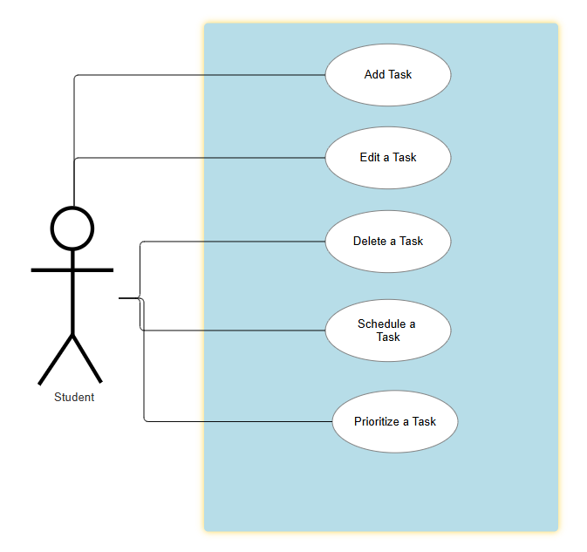
Module 2: Class Schedule
- Transaction 2.1: Input and manage class schedules
- Transaction 2.2: Auto-prioritize tasks based on class timings
- Use Case:
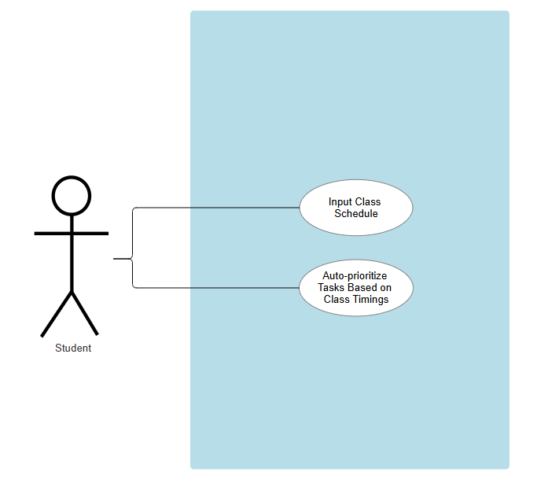
Module 3: Study Techniques
- Transaction 3.1: Implement Pomodoro Timer
- Transaction 3.2: Provide Flashcards and Quizzes
- Transaction 3.3: Track study sessions and effectiveness
- Use Case:
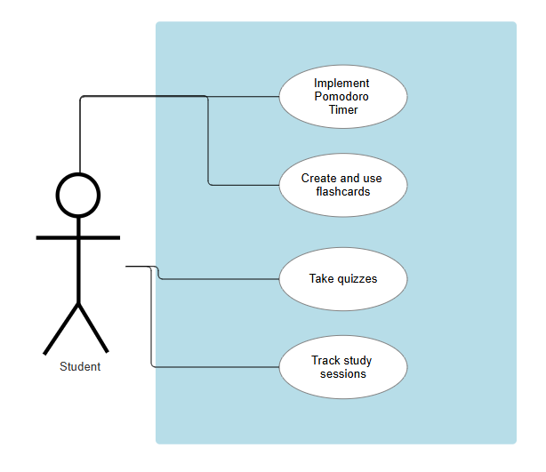
Module 4: Progress Tracking
- Transaction 4.1: Monitor task completion rates
- Transaction 4.2: Set and track study goals
- Use Case:
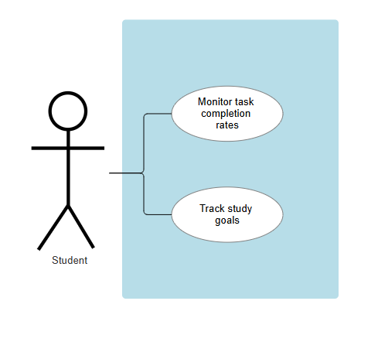
Module 5: File Management
- Transaction 5.1: Upload and organize study materials
- Transaction 5.2: Annotate and categorize notes
- Use Case:
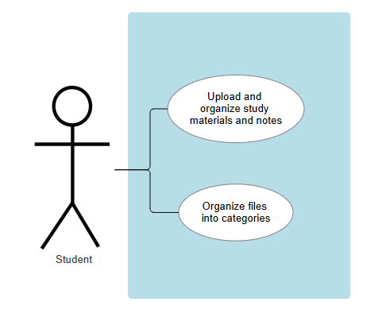
Module 6: Personalized Study Recommendations
- Transaction 6.1: Suggest study techniques based on user preferences
- Transaction 6.2: Adapt recommendations based on activity levels
- Use Case:
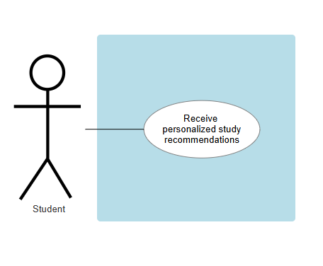
Module 7: Map Integration
- Transaction 7.1: Show nearest libraries and study areas
- Transaction 7.2: Provide navigation and availability information
- Use Case:
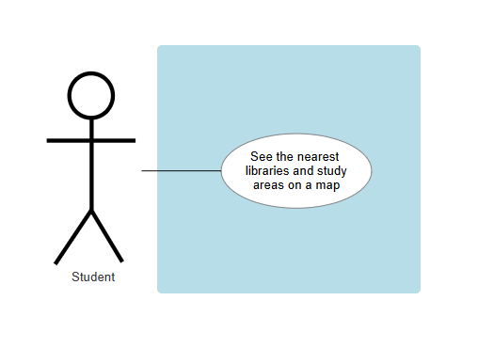
Module 8: User Authentication
- Transaction 8.1: User Registration
- Transaction 8.2: User Login
- Transaction 8.3: Password Reset
- Transaction 8.4: Account Management (e.g., updating profile information)
- Transaction 8.5: Two-factor Authentication (optional for added security)

Non-functional requirements

Performance

Details

Security

Details

Reliability

Details

